CS401 Lecture 20/11

Unsupervised Learning

K-means clustering
-sometimes called vector quantization

Error function
$\begin{aligned}E=\sum_{p}{\underset{i}{\text{min}‖x^{(p)}}}−c^{(i)}‖^{2} \\ \\ c←c−μ∇_{c}E^{(p)} \\ \\ \frac{d}{{\text{dc}}_{j}^{(i)}}E^{(p)}=\frac{d}{{\text{dc}}_{j}^{(i)}}\underset{i}{\text{min}}\sum_{j^{'}}{(x_{j^{'}}^{(p)}}−c_{j^{'}}^{(i)})^{2} \\ \\ i^{}≡\underset{i}{\text{argmin}}‖x^{(p)}−c^{(i)}‖^{2} \\ \\ \frac{d}{{\text{dc}}_{j}^{(i)}}\sum_{j^{'}}{(\underset{j^{'}}{x^{(p)}}}−c_{j^{'}}^{(i∗)})^{2} \\ \\ \begin{aligned}\left\{i≠i∗ | \right.\end{aligned}\left\{\begin{aligned}\left.\text{.}\text{.}\text{.}\text{.}\text{.}\text{.}\text{.}\text{.}\text{.}\text{.}\text{.}\text{.}\text{.}\text{.}\text{.}\text{.}\text{.}\text{.}\text{.}\text{.}\text{.}\text{.}\text{.}\text{.}\text{.}\text{.}\text{.}\text{.}\text{.}\text{.}\text{.}0 | \right\}\end{aligned}\right\}\end{aligned}$

batch K-means Hard assignment of points to clusters

Repeat
For each p,
$Z_{p}=\underset{i}{\text{argmin}}‖x^{(p)}−c^{(i)}‖^{2}$

For each cluster centre i,

$c^{(i)}=\frac{\sum_{\left\{p|z_{p}=i\right\}|}{x^{(p)}}}{|}$

until convergence

so to remove $|\left\{p|z_{p}=i\right\}|$

change rep

$z_{p}$= id of cluster closest to $x^{(p)}$

$Z_{p}^{i}=\begin{aligned}\left\{1\text{.}\text{.}\text{.}\text{.}\text{.}\text{.}\text{.}\text{.}\text{.}\text{.}\text{.}\text{.}\text{.}\text{.}\text{.}\text{.}\text{.}x^{(p)}\text{closest}\text{.}\text{to}\text{.}\text{cluster}\text{.}i | \right.\end{aligned}$

so we get
repeat for each p,
$Z_{p}^{i}=\text{.}\text{.}\text{.}\text{.}\text{.}\text{.}\text{.}\text{.}\text{.}\text{.}\text{.}\text{.}\text{.}\text{.}\text{.}\text{.}i$
for each I,

$c^{(i)}=\frac{\sum_{p}{z_{p}^{i}x^{(p)}}}{\sum_{p}{z_{p}^{i}}}$

until convergence

$$X=\left\{x^{(p)}\right\}$$
Box That Spits out Data
M
Data
X’s

Consider Gaussian distribution 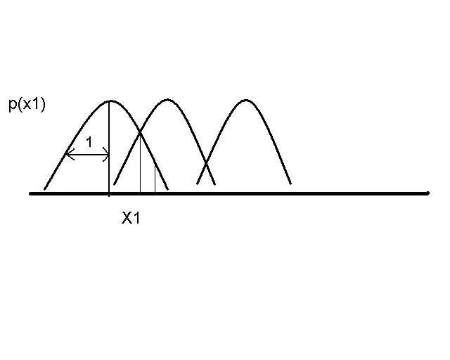

EM of G.M.M
Loop
$Z_{p}^{i}=$ How strongly $x^{(p)}$ assigned to $C^{(i)}$

$=\frac{g(x^{(p)}|c^{(i)})}{\sum_{i}{g(x^{(p)}|c^{(i)})}}\sum_{i}{Z_{p}^{i}}=1$

for each i,

$$c^{(i)}=\frac{\sum_{p}{Z_{p}^{i}x^{(p)}}}{\sum_{p}{Z_{p}^{i}}}$$

Until convergence

